Westchester Knitting Guild
September 2023 Newsletter

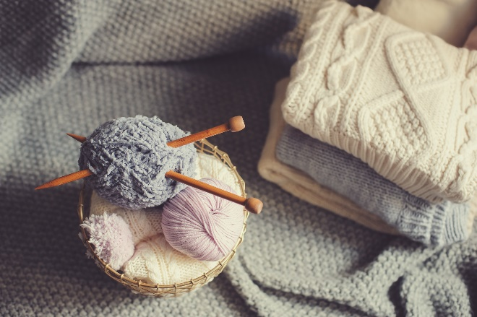

! Charity Knitting

I don’t know how you feel, but this year feels like the fastest year ever. And the December Holidays are just around the corner. This motivated me to contact some of our lucky recipients. I learned that Rochelle of Hawkwing is hoping to ship out warm clothing for those living in the reservation. When she hears from us she is so excited because she knows these items will be the best. I also contacted the Soup Kitchen to see if they would like to distribute scarves during the holidays. He was very excited to hear we will do our best. His clients can hardly believe someone would make such beautiful scarves and then give them to strangers. So, I would like to ask you once again to donate to those who are in need.
We have been most fortunate in the wonderful donations we have received this summer. You make us very proud and there are many, many people who are most grateful. I thank you in advance.
I hope to see you soon and wish you all well,
Dorothy Freeman

Letter from the President
As summer winds down we can look forward to the Fall and all the cold weather items we will be knitting, for ourselves, family and for charity. We can look forward to wonderful speakers, starting this very month.
Also to our members who volunteered to be part of the program committee, a big thank you.
As Always, Happy Knitting,
Evelyne Liebmann

Our September meeting will be in person at the Mt pleasant Library,
See you There!

Our guest Speaker for September
Hania, New York: Guest Speaker for September Anya Cole is the founder of Hania, New York, a sustainable fashion business specializing in Hand Knit, custom garments. Founded in 2012 Anya has received extensive coverage in Fashion magazines such as Vogue, industry journals such as Women’s Wear Daily. “Born in Poland, Anya pursued the creative arts from a young age, beginning with classical training in ballet, ultimately allowing her to perform with the Metropolitan Opera in Poland. In addition to dance, her inspired mind propelled her to take up knitting in order to produce the garments that her mother so keenly suggest she make for herself. Anya’s passion for knitting has continued throughout her life, and was brought with her to New York City when she moved in the late 1980’s after years spent in West Germany, where she knitted to support herself and her young daughter. Upon launching HANIA, Anya made hand knitting the heart of the brand, staying true to her background and indulging her personal passion. Today, HANIA garments are all hand knit by a community of women across New York City.” (Hania, New York website)
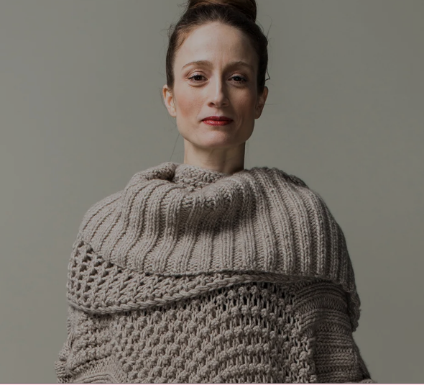
https://hanianewyork.com/

Future Event, from Suzanne Sunday:
Our November Zoom speaker will be Lesley Anne Robinson, talking about “Designing with Brioche”. More details will be upcoming, but she incorporates brioche into garments in very unique ways and is a terrific presenter.

Thank you all who turned out for the Yarn Meet Up on Tuesday the 12th. If you have anything you wish to donate, I will be at the General Meeting on 9/18 at the Mt Pleasant
Library.

Myra Cohen
Library. Please come and see me there.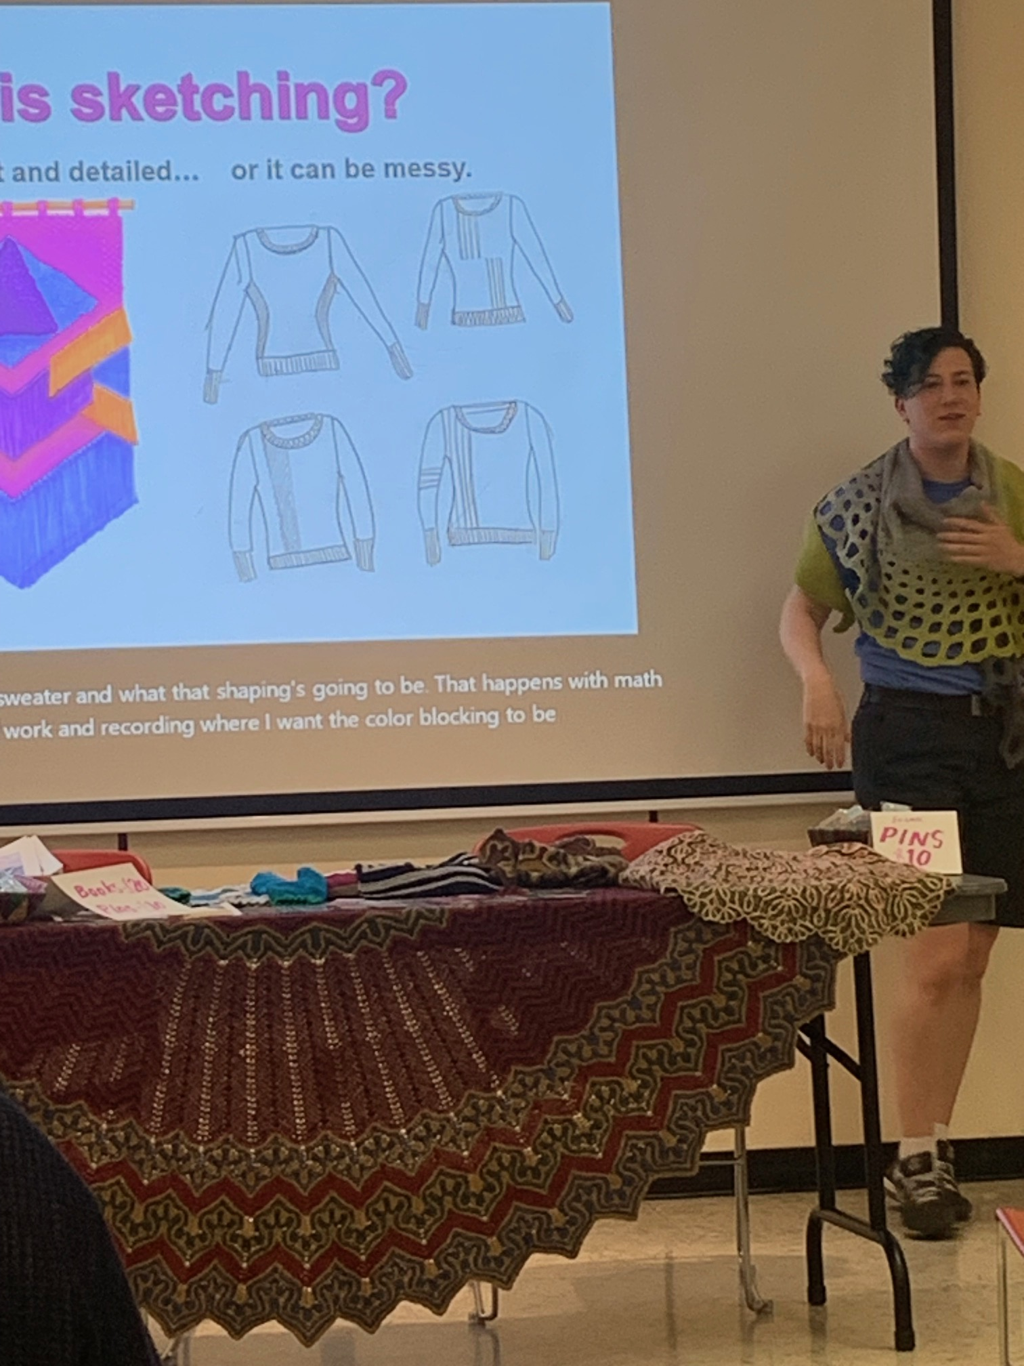

Leadership Team
J. Evelyne Liebmann, President
evelyne.liebmann@gmail.com

Suzanne Sunday, Vice President
ssunday@optonline.net

Dorothy Freeman, Charities
dorfree@verizon.net

Jeanne Scoﬁdio, Treasurer
ajsknits@gmail.com

Myra Cohen, Meeting
Coordinator
myco81@aol.com

Gail Blumenfeld, Webmaster
gailrb@yahoo.com

Susan Cabral, Newsletter
momcabral@gmail.com

Margie Laury, Recording Secretary
margielaury@yahoo.com

DISCOUNTS AT OUR MEMBER SHOPS

The following businesses will give a 10% discount on non-sale items to members of the Westchester Knitting Guild with current membership ID cards. Current membership card must be presented to receive discount. As is currently the case with all retail businesses, please contact before going to find out if appointments are necessary.

Cornwall Yarn Shop
227 Main Street
Cornwall, NY 12518
845-534-0383
Owner: Gail Parrinell
Cozy Corner Yarn Shop
116 Washington Street
Peekskill NY 10566
914-737-0179
Owner: Janet Hard

Knitty City
208 W. 79th St.
New York, NY 10024
212-787-5896 (212-purl-two)
Pick Up Every Stitch
200 E. Main Street
​Mt. Kisco, NY 10549
914-864-2828
pickupeverystitch@gmail.com
Yarn and Craft Box
24 Charles Blvd.
Pawling, NY 12564
845-855-1632
Owner: Marie Stewart

For our youtube library and links from Raina Laredo, Joan Conca, Carol Feller and Susan Levitt:

From Jane Daniels:
A founding member of the Westchester Knitting Guild, Jane Daniels' love affair with knitting started in1963 when she was in college. Along the way, she has knit too many sweaters, mittens, and scarves to count, but she did decide to keep track of how many hats she has knit.
Thought the guild would be interested in an article I wrote for PLY magazine. See
https://plymagazine.com/2022/02/the-hat-queen/
From Guild Member Melissa Shinsato:
I teach at the adult schools of Bronxville & Scarsdale and frequently recommend these websites to my knitters.
For general how-tos I recommend Webs or KnitPicks. The 2 sources below are gifted knitters in both their skill & ability to explain and demonstrate.
10 Rows a Day
Nimble Needle
YouTube Nimble Needless
His youtube channel is a wealth of information and detailed demos.
As an aside - I would truly love a youtube channel with good left handed knitting instruction. Turns out a good one is hard to find.
Techniques: Short Rows

Short rows create wedges in knitting to create shaping for bust darts, sock heels, ear flaps — basically to build volume within the edges of knitting to change the shape. There are several different methods and the choice to use one over another can vary from personal preference to carefully matching the best technique for a yarn and project.

Three common methods are Wrap & Turn, German and Japanese. There are many online resources for investigating which method may work best for a project. Here are some links to get started on tutorials by different sources— for live links visit our website homepage or go directly to:
https://www.westchesterknittingguild.com/journal/tips-and-techniques-short-rows.

Wrap & Turn (wrapping the working yarn around a stitch)
Pros: Best for knitted lace or looser fabrics
Cons: Can create loose spots since the wraps add extra yarn
Online video tutorial and photo tutorial by Purl Soho: https://www.purlsoho.com/create/short-rows-wrap-turn/

German (using a slipped and lifted stitch)
Pros: Simpler than Wrap & Turn; creates smooth fabric
Cons: Make sure to review how to convert from a Wrap & Turn short row if German is not specified (shown in video below)
Online video tutorial by VeryPink Knits: https://youtu.be/52qy8OOb-s0

Another German Short Row video by Mimi Kezer:
https://youtu.be/i_6Pjl20zKA

Japanese (using a stitch marker to lift and slip a stitch)
Pros: Best for smooth yarns that may show unevenness in a short row since this method creates the least amount of looseness in stitches
Cons: More fiddly than other methods
Online video tutorial by Holli Yeah : https://youtu.be/F3CIOMsVcLM

Patterns that use short rows
Here are three free short row patterns for trying out different methods:
Bandana Cowl by Purl Soho
Ravelry Link: https://ravel.me/bandana-cowl

Pieces of Eight Mitts by Sybil R
Ravelry Link: https://ravel.me/pieces-of-eight-mitts

Yarn Crawl Hat 2019 by Buffalo Ása Designs
Ravelry Link: https://ravel.me/garngonguhufan-2019---yarn-crawl-hat-2019

Provisional Cast on: by Solene Le Roux

https://youtu.be/so4ZcrZlKKQ
Stretchy Italian Cast On: excellent for brioche:
https://youtu.be/U1s77uZUqlg

Hand Yoga
https://m.youtube.com/watch?v=TJM8zQWdWhI
https://m.youtube.com/watch?v=8sGdLCopN80

